# 

Questionnaire Management System   
User Interface Specification

CSE454 – Advanced Software Engineering

Team Members:

Abdallah Amir Monir

Ahmed Abed Haseeb

Ahmed Ehab Mohammed

Khaled Saeed Zahran

Mazen Ehab Fathy

*Under Supervision of:*

*Dr. Ahmed Badawy*

*Eng. Aya Ibrahim*

Table of Contents

Signup/Registration Page 3

Login Page 4

Forget/Reset Password Page 5

Admin Dashboard Page 6

User Profile Page 7

Create Questionnaire page 8

View Questionnaires Page 9

Create Questionnaire Modules Page 10

View Questionnaire Modules Page 11

User Management – View Users page 12

User Management – Roles & Permissions Page 13

# Registration Page

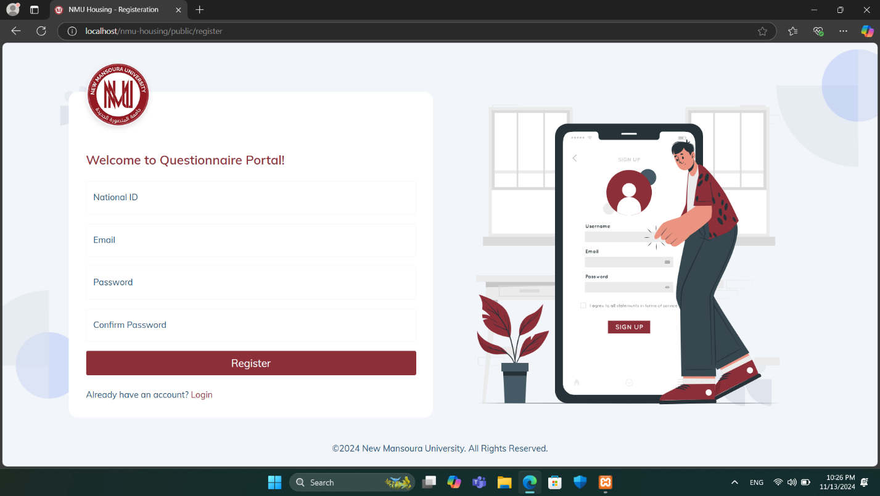

The **Registration Page** is the entry point for new users to sign up for access to the **NMU Questionnaire Portal**. This page requires users to fill in the following fields:

* **National ID:** A unique identifier required for user verification.
* **Email:** The user's email address, which will be used for communication and login purposes.
* **Password:** A secure password created by the user.
* **Confirm Password:** Ensures accuracy by requiring users to re-enter their password.

After filling out these fields, users can click the **Register button to complete the sign-up process**.

A link below the registration form allows users who already have an account to quickly switch to the Login page. The welcoming design and clear instructions make the sign-up process simple and user-friendly, encouraging ease of access to the questionnaire system.

# Login Page

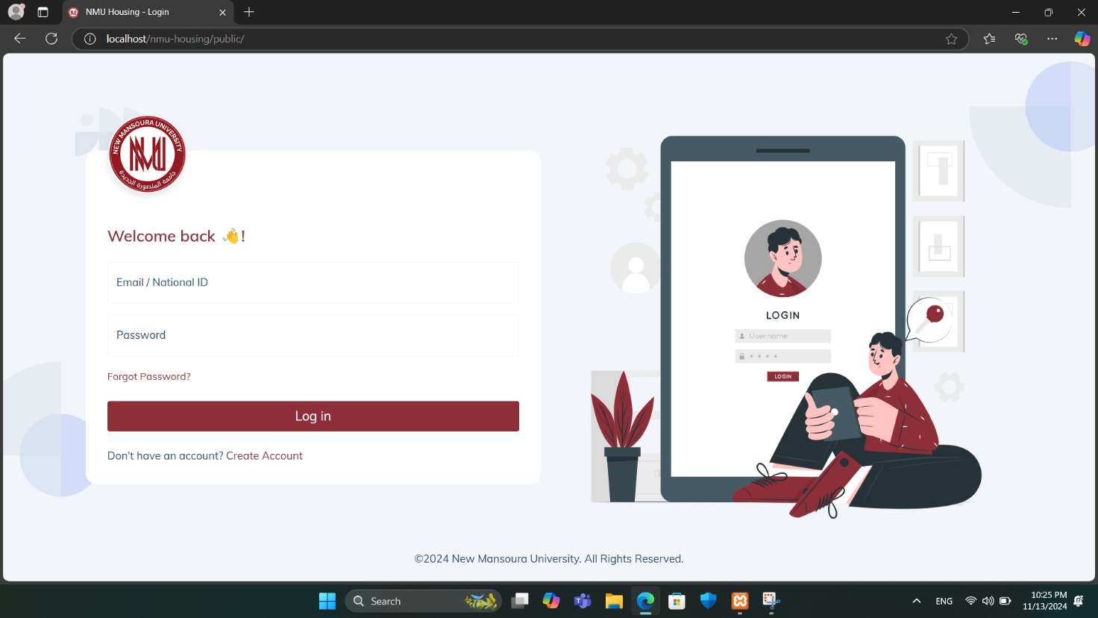

The **Login Page** contains the following:

1. **Logo and Welcome Message**:
   * The New Mansoura University logo is prominently displayed to reinforce brand identity.
   * A welcoming message ("Welcome back!") creates a friendly atmosphere for returning users.
2. **Login Fields**:
   * **Email / National ID**: Field to enter either an email address or a National ID, catering to diverse login preferences.
   * **Password**: Field for users to enter their password securely.
3. **Additional Options**:
   * **Forgot Password?**: A link for users to recover their password if forgotten, improving user experience.
   * **Don’t have an account? Create Account**: A prompt for new users to register for an account if they don't already have one.
4. **Login Button**:
   * A large, clearly visible **Log in** button to submit login credentials and access the system.

# Reset Password Page

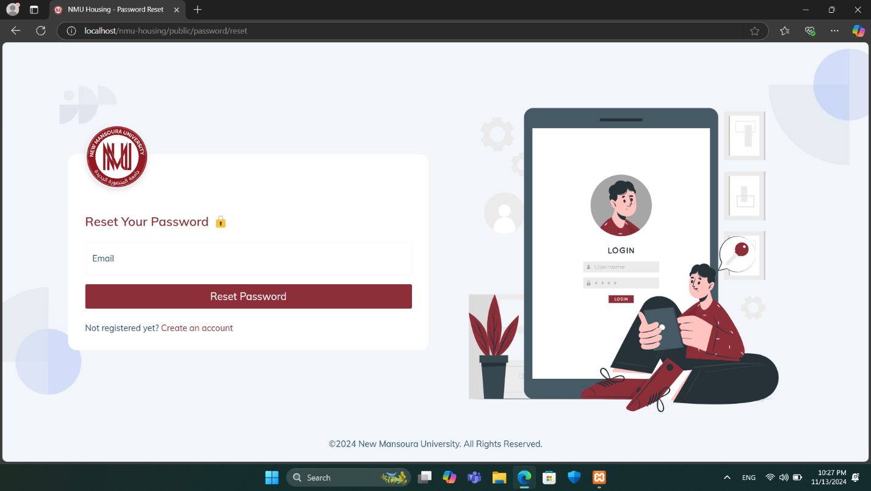

The **Reset Password page** allows users to recover access to their account by requesting a password reset.

* **Email Field:** Users enter the email associated with their account.
* **Reset Password Button:** Initiates the password reset process. Upon clicking, the system verifies the email and, if valid, sends reset instructions to the user’s email.
* **Account Creation Link:** A link for users who are not yet registered, providing a direct path to create an account.

This page ensures a straightforward process for account recovery.

# Dashboard Page

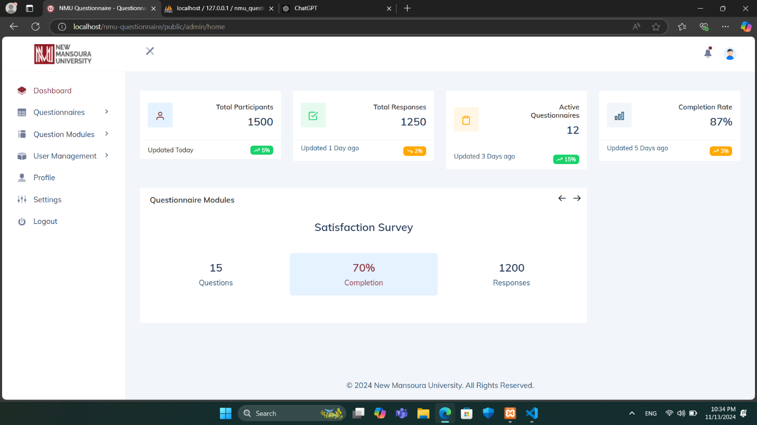

The **Dashboard page** provides an overview of key metrics and statistics related to questionnaires within the system. It includes the following sections:

* **Statistics Summary:** Displays key metrics, including:
* **Total Participants:** Shows the total number of users who participated in questionnaires, with the last update time and recent change percentage.
* **Total Responses:** Indicates the number of questionnaire responses, along with an update timestamp and recent change percentage.
* **Active Questionnaires:** Lists the number of currently active questionnaires, along with recent activity indicators.
* **Completion Rate:** Provides the overall completion rate of questionnaires, showing the percentage and last update details.
* **Questionnaire Modules:** Displays active modules containing preset questions, such as the "Satisfaction Survey." For each module, the system shows the current completion percentage, the number of responses, and the total number of questions. Arrows allow navigation through different modules if multiple sets of preset questions are available.

The left sidebar provides navigation options for accessing other sections, including Questionnaires, Question Modules, User Management, Profile, Settings, and Logout.

# Profile Page

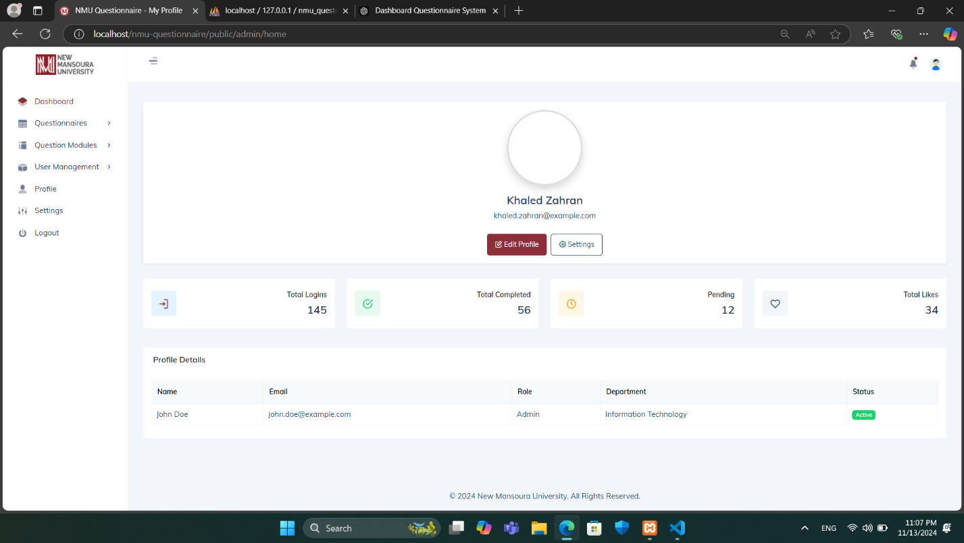

The **Profile page** provides users with an overview of their account details and activity. At the top, the user’s name and email are displayed, accompanied by options to Edit Profile and access Settings for customization. Below this section, a summary of key metrics is shown, including:

* **Total Logins:** Displays the number of times the user has logged into the system.
* **Total Completed:** Indicates the number of questionnaires or activities completed by the user.
* **Pending:** Shows the count of pending tasks or questionnaires assigned to the user.
* **Total Likes:** Reflects the total likes or approvals received, potentially from other users or administrators.

In the **Profile Details section**, information such as the user’s name, email, role (e.g., Admin), department (e.g., Information Technology), and account status (e.g., Active) is displayed. This provides a quick reference to the user’s role and departmental association within the system.

This page allows users to monitor their engagement within the system and keep track of their profile information and activity status.

# Create Questionnaire page

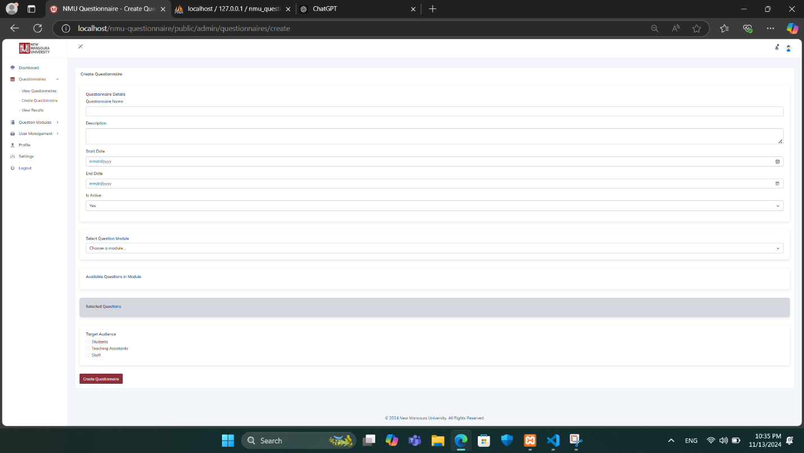

The **Create Questionnaire page** contains the following:

1. **Questionnaire Details**:
   * **Questionnaire Name**: Field for entering the name of the questionnaire.
   * **Description**: Field to provide a brief description or purpose of the questionnaire.
   * **Start Date & End Date**: Date pickers to set the active period for the questionnaire, specifying when it will be available to respondents.
   * **Is Active**: Option to toggle the active status of the questionnaire.
2. **Select Question Module**:
   * **Choose a Module**: Dropdown menu to select a preset question module created earlier. This enables the reuse of standardized question sets across multiple questionnaires.
   * **Available Questions in Module**: Displays the questions within the selected module for review.
3. **Selected Questions**:
   * Displays a list of questions selected from the module or added manually.
4. **Target Audience**:
   * Options to select the intended audience for the questionnaire, such as **Students**, **Teaching Assistants**, or **Staff**.
5. **Controls**:
   * **Create Questionnaire**: Button to save and deploy the questionnaire with the selected modules and settings.

This page enables administrators to customize questionnaires based on specific objectives, target audiences, and timelines, making it easier to manage diverse survey requirements.

# View Questionnaires Page

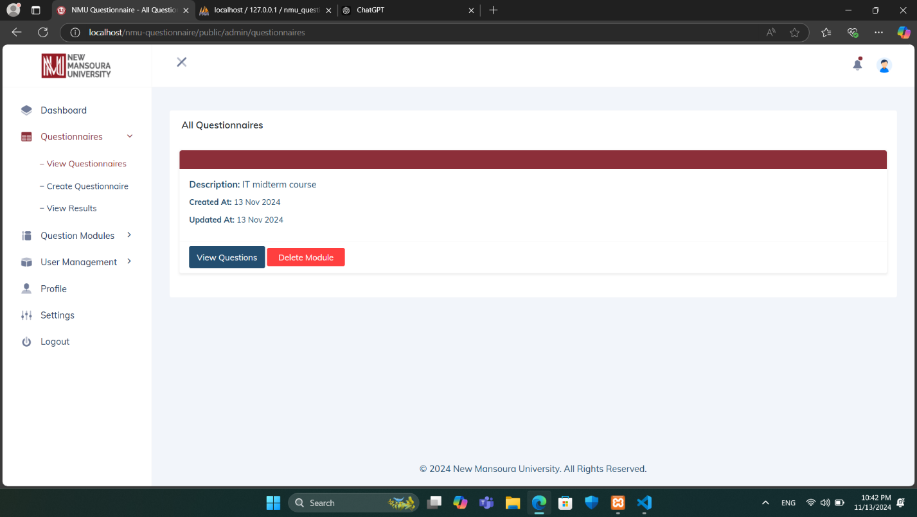

The **View Questionnaires page** provides a comprehensive list of questionnaires available within the system. Each questionnaire entry displays key information, including a brief Description (e.g., "IT midterm course") and the dates when it was Created and Updated.

For each questionnaire, users have two primary actions available:

* **View Questions:** Opens the questionnaire for a detailed view of all questions included within this specific module.
* **Delete Module:** Permanently removes the questionnaire from the system.

The left sidebar offers quick navigation to other areas of the application, including Questionnaires (for viewing, creating, and analyzing results), Question Modules, User Management, Profile, Settings, and the option to Logout.

This page is particularly useful for administrators and educators to manage and track questionnaires efficiently, ensuring that they can access, update, or delete questionnaires as needed.

# Create Questionnaire Modules Page

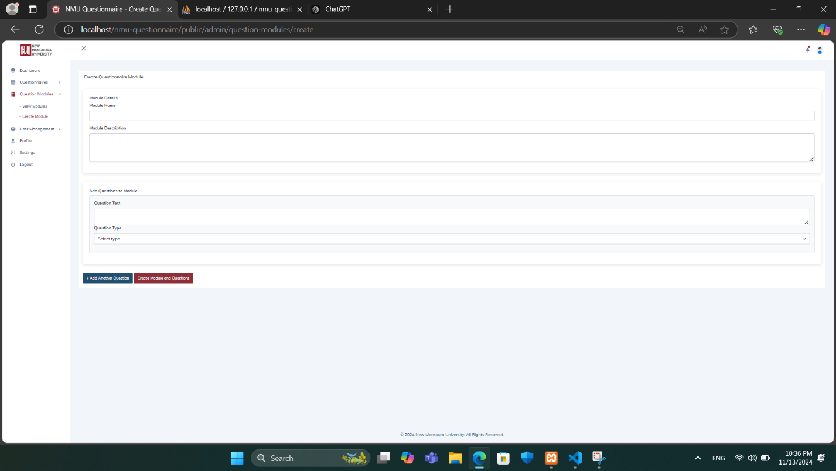

The **Create Questionnaire Modules** **page** contains the following **Module Details**:

* **Module Name:** Field for naming the module to describe its purpose (e.g., "Course Feedback").
* **Module Description:** Field to provide additional context about the module.
* **Add Questions to Module:** Button to add questions to the module.
* **Question Text:** Field to enter the text of each question to be included in the module.
* **Question Type:** Dropdown menu to select the type of question (e.g., multiple-choice, short answer, rating scale).
* **Create Module and Questions:** Button to save the module and its questions, making it available for use in questionnaires.

This page is designed to streamline the creation of standardized question sets, facilitating easier and more consistent questionnaire building.

# View Questionnaire Modules Page

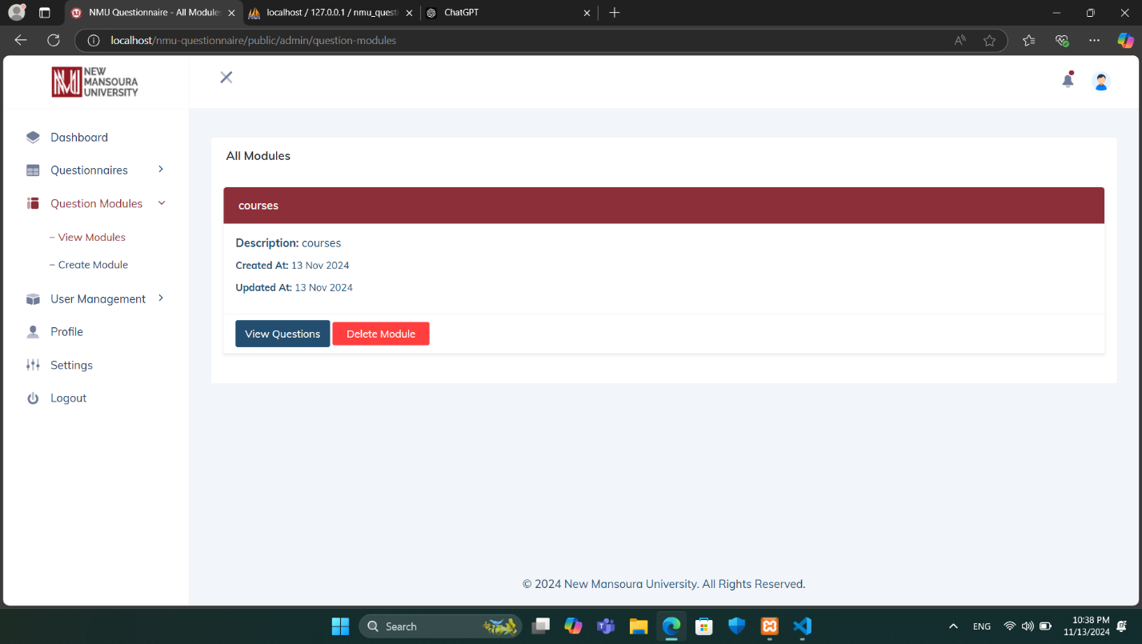

The **View Questionnaire Modules** page within the **Question Modules** section provides administrators with an organized view of available questionnaire modules in the system.

In the main panel, each module is displayed with the following details:

* **Title**: The name of the module, shown prominently in a red header for clear identification.
* **Description**: A brief description summarizing the purpose of the module.
* **Created At**: The date when the module was created.
* **Updated At**: The date of the last update to the module.

For each module, administrators have two main options:

* **View Questions**: This button allows the administrator to view all questions associated with the selected module.
* **Delete Module**: This button enables the administrator to remove the module from the system.

This page serves as a centralized interface for administrators to manage questionnaire modules, ensuring streamlined access to module details and maintenance options.

# User Management – View Users page

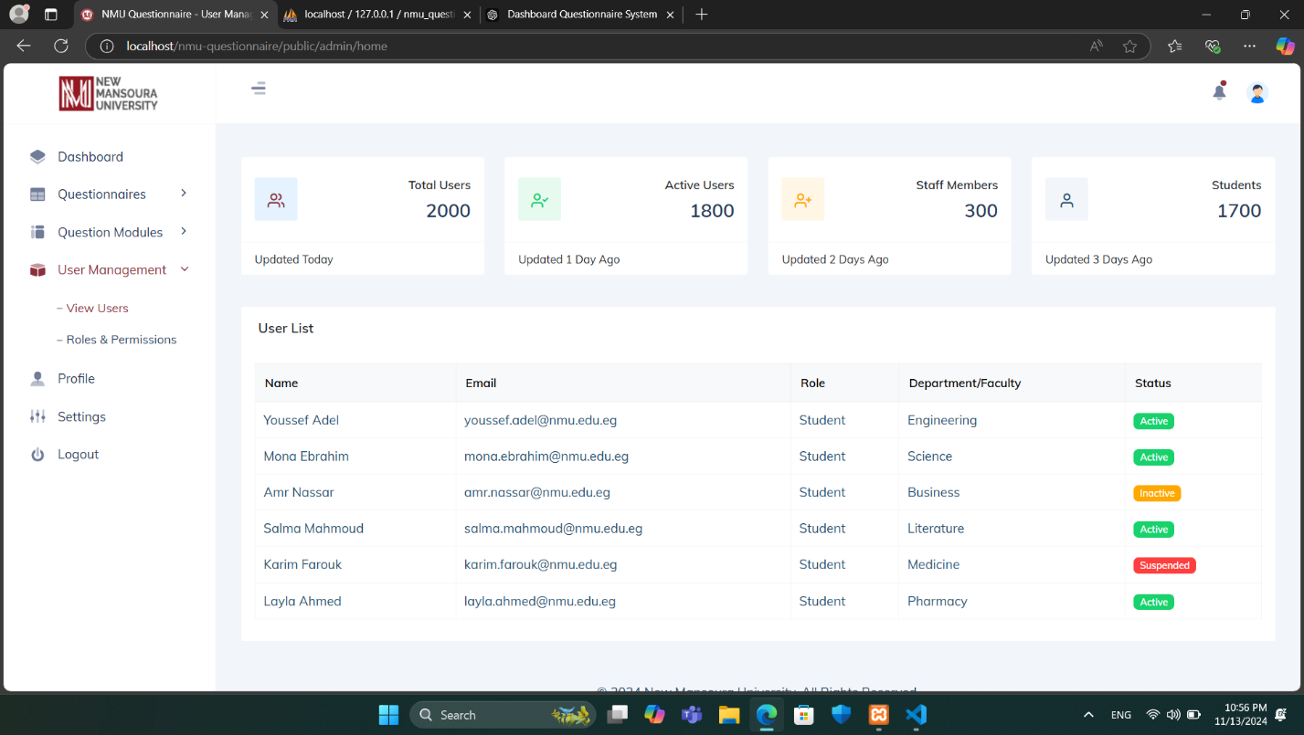

The **View Users page** within **User Management** provides administrators with an overview of system users and key statistics. **At the top of the page, a series of summary cards display:**

* **Total Users:** The total number of users registered in the system.
* **Active Users:** The count of users who are currently active.
* **Staff Members:** The number of users who are staff members.
* **Students:** The count of users identified as students.

**Each card includes the date of the last update for reference.**

Below the summary, the **User List table** provides a detailed view of individual users. The table displays information such as:

* **Name:** The user’s name.
* **Email:** The user’s email address.
* **Role:** The role assigned to the user, such as “Student” or “Staff.”
* **Department/Faculty:** The department or faculty associated with the user.
* **Status:** The current status of the user, displayed as color-coded labels for easy identification, including “Active” (green), “Inactive” (yellow), and “Suspended” (red).

This page allows administrators to monitor and manage user information at a glance, helping maintain an organized and secure system.

# User Management – Roles & Permissions Page

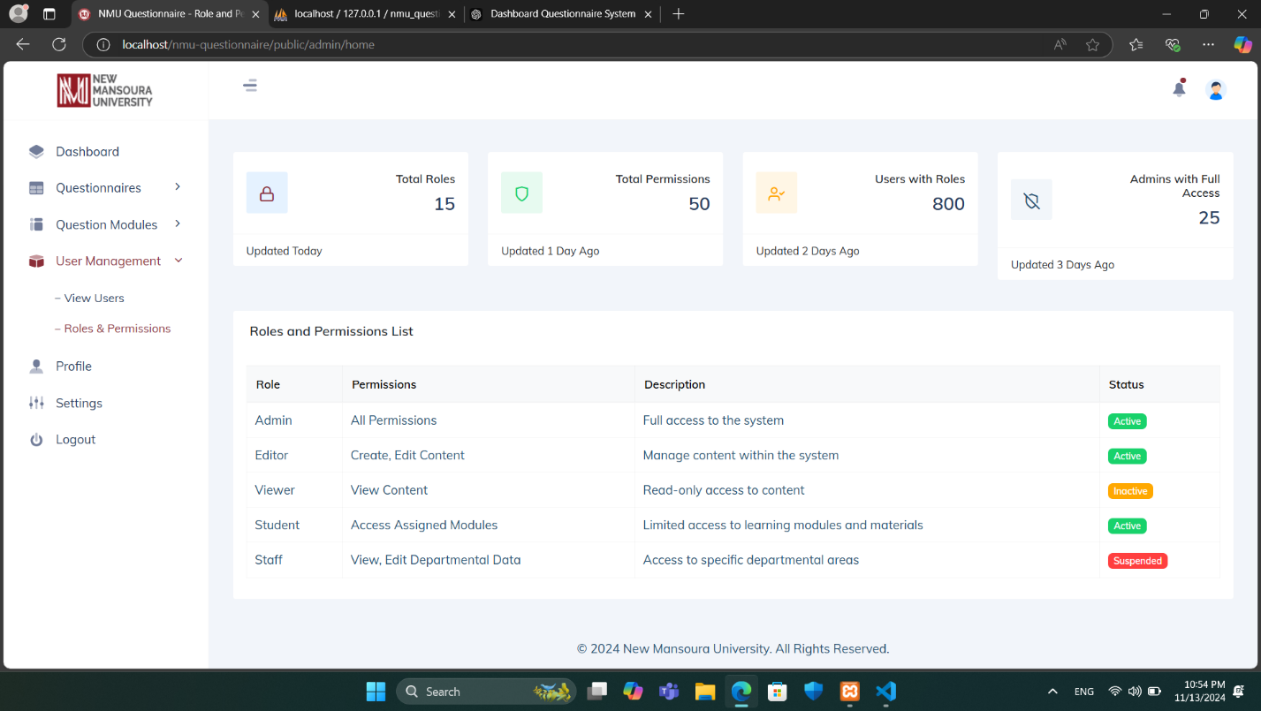

The **Roles and Permissions page** within **User Management** provides an overview of user roles within the system, along with their associated permissions and statuses. Key components of this page include:

* **Total Roles:** Displays the total number of unique roles in the system.
* **Total Permissions:** Shows the total number of distinct permissions assigned across roles.
* **Users with Roles:** Indicates the total number of users with assigned roles.
* **Admins with Full Access:** Shows the number of administrators who have full system access.
* **Role:** Lists different roles, such as Admin, Editor, Viewer, Student, and Staff.
* **Permissions:** Describes the permissions associated with each role, such as full access, content editing, view-only access, or access to specific modules.
* **Description:** Provides a brief description of the responsibilities or access level associated with each role.
* **Status:** Indicates the current status of each role (e.g., Active, Inactive, Suspended).

This page helps administrators manage user access and maintain system security by defining role-based permissions.